# How to Patch Clothes

I grew up in the 50s when clothes were still expensive and were patched to make them last. I find it odd that people do not know how to do this. If you are one of those who has never had to patch anything, this is for you.

The first thing to consider when facing a hole in your clothes is what sort is it? If a tear, it can possibly be sewn up without needing a patch. If it is wear, a patch will be needed. Either way, you sew it up. Do not use a seam stitch. What I do is sew through the cloth on one side of the split, take the needle through the hole and sew through the other cloth on the other side of the hole, trying to keep the cloth as flat as if there was not hole. If the hole is wear, I do this across then back down, weaving through the previous threads. The photo below shows both methods.

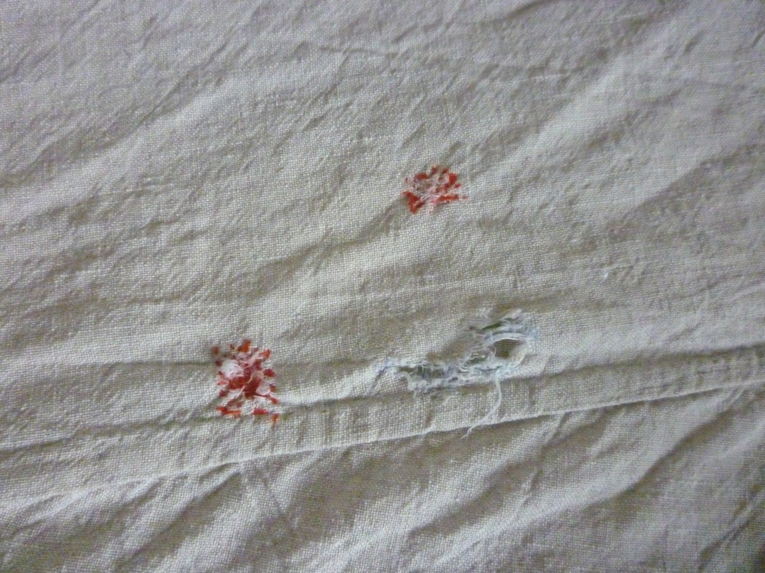

As you can see, the tear is tearing again. I should have patched it as well.

When applying a patch always use fabric of the same weight and type of fabric as your garment. (That is why you keep your offcuts when making garments.) Cut a piece big enough to cover the darn with a big enough margin for a hem. Place the area on a flat surface and position your patch over the darn. Pin it in place, fold the edges under and oversew into position. Or you can be decorative and use something like a herringbone stitch, if you want to show off.

It helps enormously if you have a darning mushroom to keep the fabric flat and in position.

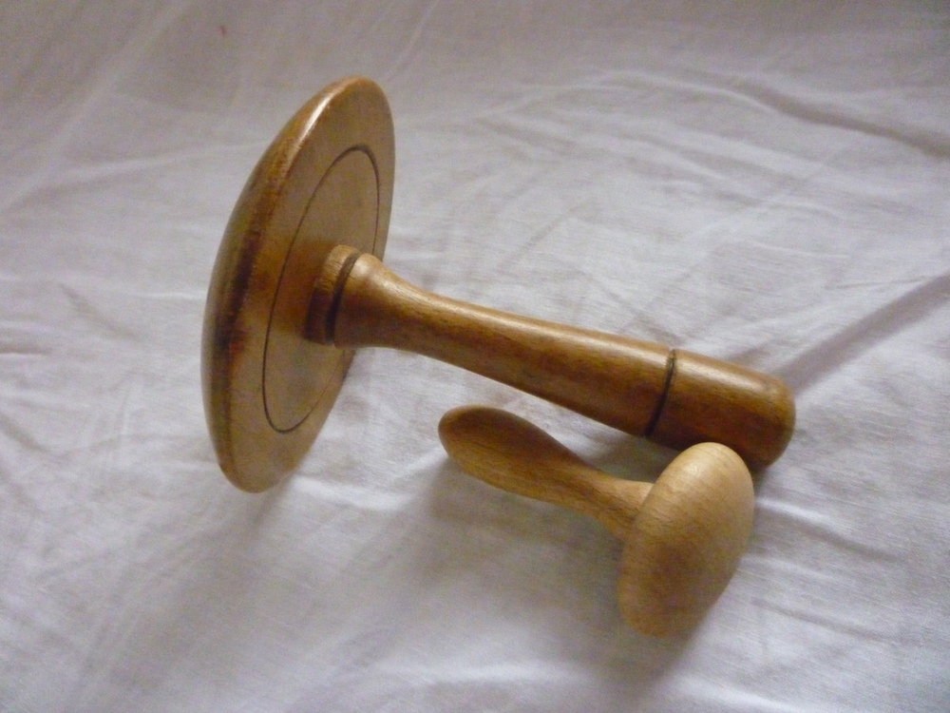

You stretch the fabric over the rounded surface and grip it around the handle, enabling you to hold the fabric and the mushroom in one hand while sewing with the other. The little one is for socks. The larger one is not only useful for mending clothes but also when making them. I find it particularly useful when tackling the fiddly bit under the arm where the sleeve fits into the body.

I do not have a source for darning mushrooms. Maybe one of our wood-turning friends would like a new product to sell? It needs to be of hardwood. Beech is best, IMO, and will last a lifetime.